EDGE INTELLIGENCE
LAB – 1

GAURAV SURESH BABU
25MML0019

Tasks:
1. Identify Jupyter Notebook
2. Open Jupyter Notebook
3. Choose a Dataformat
4. Choose a Dataset
5. Load the Dataset

Implementation:
This implementation utilizes the Animal 10N dataset, providing an equal split of 5,000 training and 5,000 testing images. The dataset is easily fetched by importing the Deeplake library and loading it directly from the provided URL
Importing libraries:

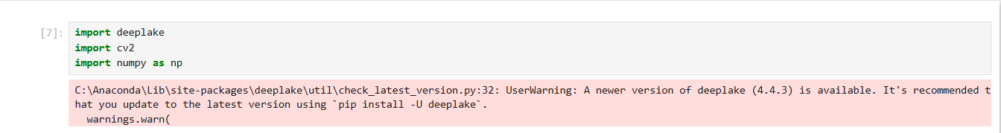

Loading the dataset:

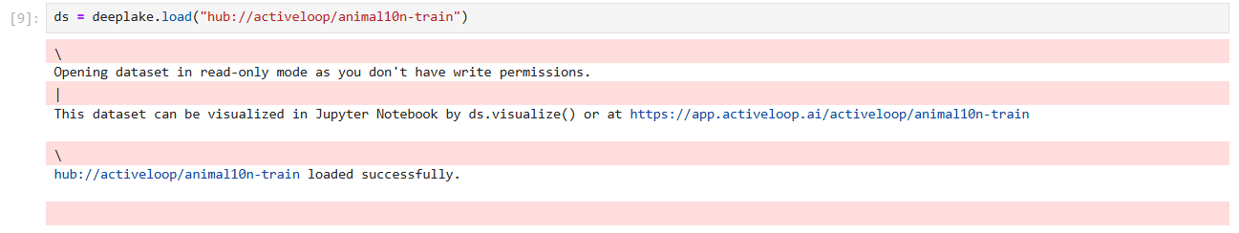

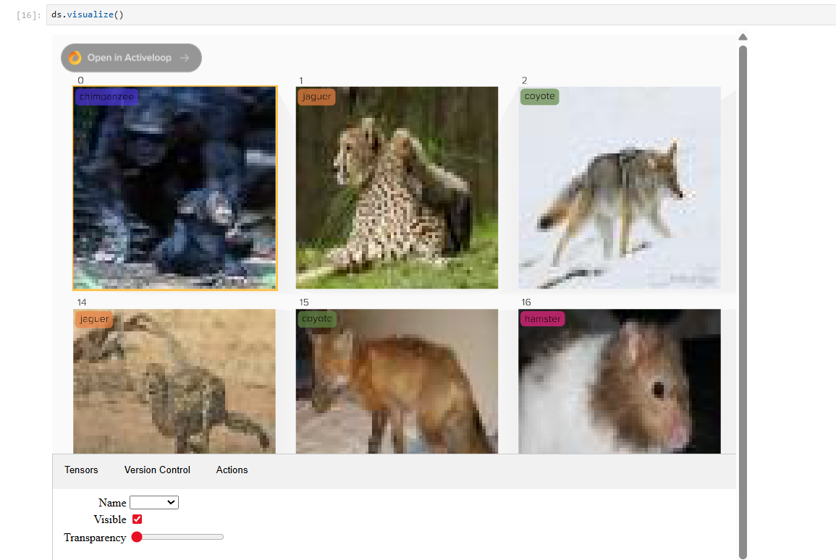

Checking if images are of same size:
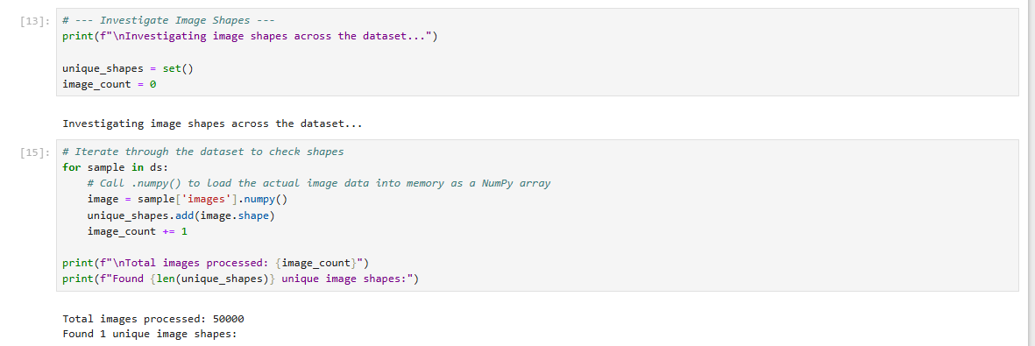

Error:
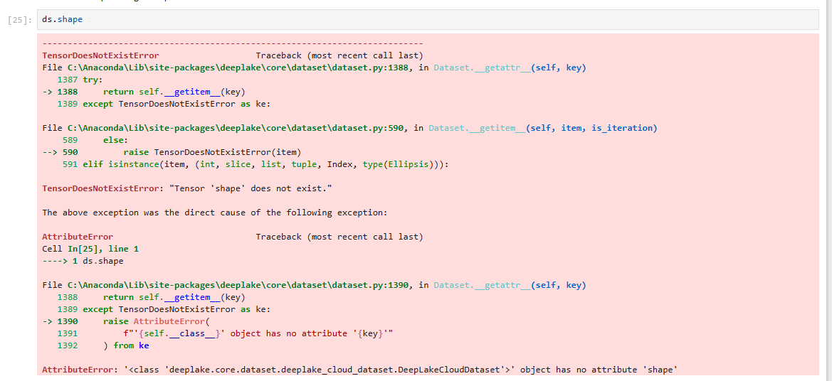

Rectification: Error can be rectified by inclusing tensor images as ds.images.shape

Showing the first 30 images:
Error:
You asked plt.subplot(2, 5, i+1) which creates a grid of 2×5 = 10 subplots. But your loop goes to i=29 (30 iterations), so when i+1 becomes 11 you get the error — there is no "slot 11" in a 2×5 grid.
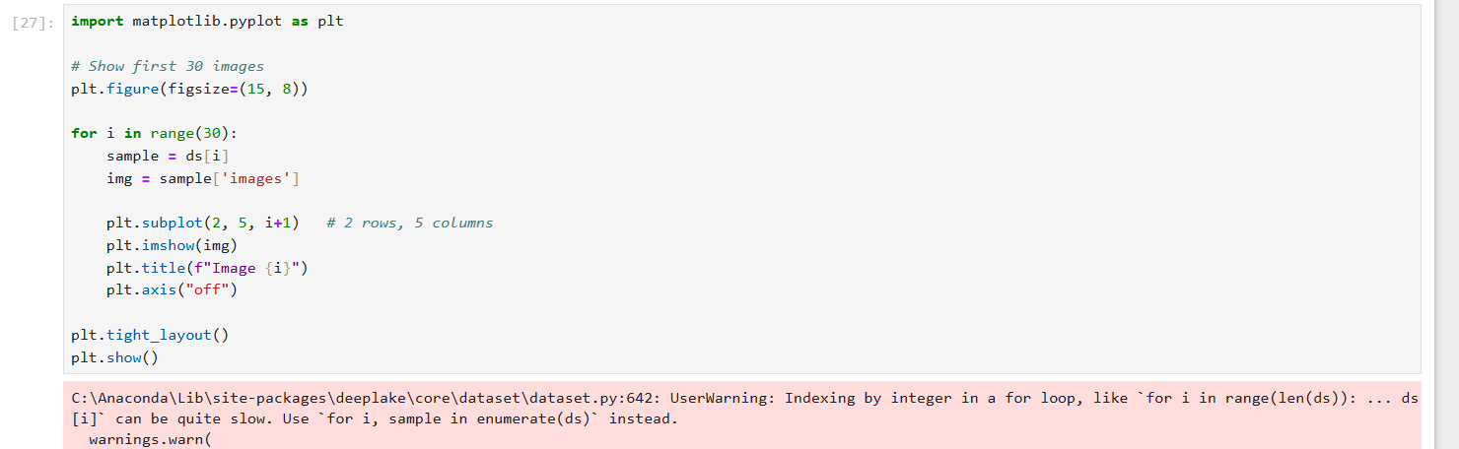

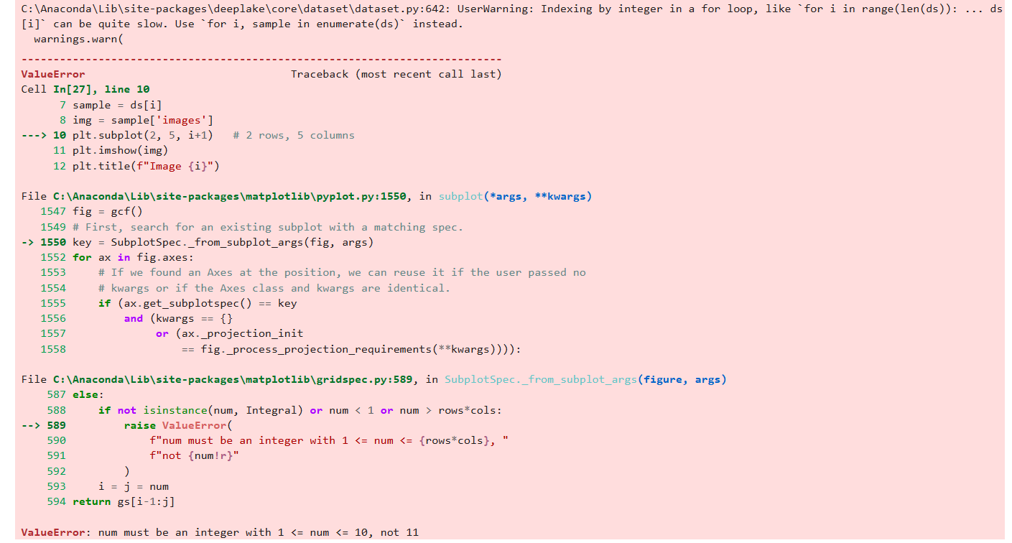

Error Rectification:
Make the grid big enough for 30 images (for example 6×5 or 5×6), or
Only plot up to the number of slots in your current grid (10)

